Yancarlos Diaz

Project Proposal

1. **App title**

Tiger Job Search

1. **App definition statement, e.g.:**
   * What does it do?

The app provides a simple interface to look for software engineering jobs

* + Who's it for?

It’s meant for RIT students looking for jobs but can really be used by any software developer looking for a job.

* + What niche does it fill?

The app pulls information from open source APIs designed by and for software developers, which guarantees a more focused search.

* + What differentiates it from the competition?

Unlike most job search engines, this one specializes on software engineering jobs or jobs related to software. It will also allow users to search for jobs that require the skills they already have.

1. **Brainstorm features**
   * **List out all of the features that you might like to have in the app. Don't hold back; list everything you can think of.**
     + Job search based on description
     + Job title auto complete
     + Job search based on skill
     + Skill name auto complete
     + Skill frequency
     + Job search based on city
     + Job search based on current location
   * **Then refine the list. Don't delete anything; just cross out the items that you don't want to actually include. What are the key features that most users of your app will want to use?**
     + Job search based on description
     + ~~Job title auto complete~~
     + Job search based on skill
     + ~~Skill name auto complete~~
     + ~~Skill frequency~~
     + Job search based on city
     + Job search based on current location
2. **Competitive analysis**
   * **Review at least one similar**[**iOS app**](https://itunes.apple.com/in/genre/ios/id36)**and one similar**[**Android app**](https://play.google.com/store/apps?hl=en)**.**
   * **For each app, include:**
     + **the name of the app**
     + **its general features**
     + **its strengths and weaknesses**
     + **the features you think it's missing**
   * **App 1** 
     + App Name: Indeed
     + Features: The app allows you to create a profile, upload documents and apply to jobs.
     + Strengths and weaknesses: The app allows you to apply to the jobs through the website, which is convenient. However, I find that this in itself is also a weakness; employers are less likely to notice you when you apply through a third-party website where thousands of other people are also applying.
     + I wish I could search for jobs without having to create an account (I actually forgot my account credentials and I had to reset them to test the app.)
   * **App 2**
     + App Name: LinkedIn
     + Features: Much like indeed, you can create a profile and directly apply to jobs. However, LinkedIn is more of a social media outlet.
     + Strengths and weaknesses: Unlike Indeed, LinkedIn’s only focus is not to apply or post jobs; you can also follow professionals and learn from them. This makes it a great website for what some people call a “passive” job search. However, just like with indeed, employers are less likely to hire someone who applies through LinkedIn than someone who applies through the company’s website.
     + Just like Indeed, LinkedIn doesn’t allow you to search for jobs without an account.
3. **Rough mockup**
   * **Create a mockup or wireframe of at least one page of your app, either by hand drawing or using a tool such as [NinjaMock](https://ninjamock.com/" \t "_blank),**[**Balsamiq**](https://balsamiq.com/download/)**,**[**Sketch**](https://www.sketchapp.com/get/)**,**[**Adobe XD**](https://creative.adobe.com/products/download/xd?promoid=WKRCJH7G&mv=other)**,**[**etc**](https://www.creativebloq.com/wireframes/top-wireframing-tools-11121302)**.**
   * 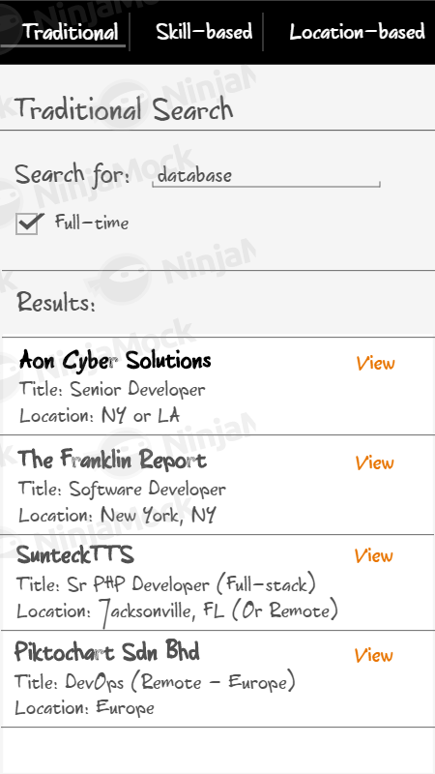
4. **Technologies  
   List which of each you'll be using:**
   * Ionic template
     + Tabs
   * Cordova plugin
     + In-app browser – to display the website where each job is posted
     + Geolocation – to grab the user’s location and find jobs around them
   * Third-party APIs (2)
     + Github Jobs - <https://jobs.github.com/api>
     + Open Skills Api - <https://github.com/workforce-data-initiative/skills-api/wiki/API-Overview>